Analyzing Data on Toronto's Public Transportation System

Thesis question
How do cloud cover, precipitation, temperature, date of week, time of day, bus routes, bus route direction, route ridership, number of stops, number of trips per six weeks and geographic area affect the punctuality as determined by average time between scheduled arrival at stops and actual arrival at stops, and speed of buses and streetcars in the Toronto Transit Commission in Spring-Summer 2014?

Variables
Variable | Quant/Qual? | Discrete/Continuous?
Weather | Qualitative (Descriptive)
Cloud Cover | Quant | Continuous
Precipitation | Quant | Continuous
Temperature | Quant | Continuous
Date of Week | Qualitative (Categorical)
Time of Day | Quant | Continuous
Bus Route | Qualitative (Categorical)
Bus Direction | Qualitative (Categorical)
Route Ridership | Quant | Continuous
Number of Stops | Quant | Discrete
Number of Trips per Six Weeks | Quant | Discrete
Geographic Area | Qualitative (Categorical)
Punctuality | Quant | Continuous
Speed | Quant | Continuous
All variables are easily measured and there is accessible public data for all variables. The dependent variables are punctuality and speed of the vehicles, and the independent variables are all the others.

Sampling Method
The sampling method is census since all vehicles are included, but also systematic since the data is collected every two minutes.

Statistics and Graphs

Number of Trips and Number of Routes
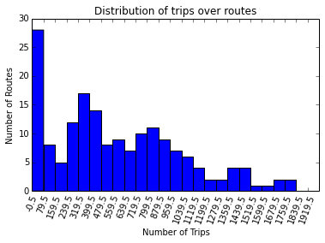
A trip is a vehicle departing from an endpoint of a route moving to the other end of a route. Over six weeks, the distribution of trips over the routes is graphed.
count 173.000000
mean 597.156069
std 445.952944
min 13.000000
25% 261.000000
50% 525.000000
75% 881.000000
max 1814.000000
dtype: float64
Pearson's: 0.485405940789
IQR: 620.0
Despite the large mode on the left of the histogram, the Pearson's Index indicates that the data is not as skewed as it seems. As well, since only 9 of the 182 routes are outliers, the data can be considered non-skewed. For us, this means that while routes vary by up up to 1801 trips over six weeks, most routes are fairly close to the median of 554 trips over a six week period.

Ridership and Costs
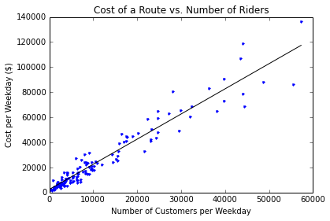
-------------------------Summary of Regression Analysis-------------------------

Formula: Y ~ <x> + <intercept>

Number of Observations: 138
Number of Degrees of Freedom: 2

R-squared: 0.9276
Adj R-squared: 0.9270

Rmse: 7045.0030

F-stat (1, 136): 1741.2502, p-value: 0.0000

Degrees of Freedom: model 1, resid 136

-----------------------Summary of Estimated Coefficients------------------------
Variable Coef Std Err t-stat p-value CI 2.5% CI 97.5%
--------------------------------------------------------------------------------
x 2.0056 0.0481 41.73 0.0000 1.9114 2.0998
intercept 2478.4971 815.2188 3.04 0.0028 880.6683 4076.3258
---------------------------------End of Summary---------------------------------

The regression here indicates (expectedly) that the cost of a route is strongly positively correlated with the number of daily riders it serves. We can interpret the coefficients as indicating that every additional rider adds a cost of $2 to the route, with a fixed cost of ~$2500.

Types of Vehicles
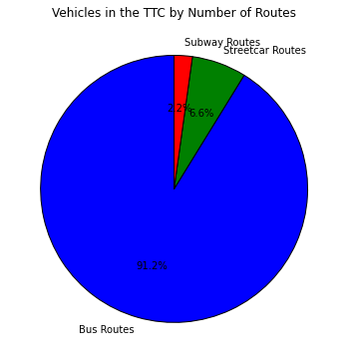
Bus routes: 166
Subway routes: 4
Streetcar routes: 12
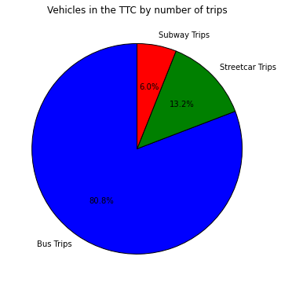
Bus trips: 101427
Subway trips: 7586
Streetcar trips: 16506

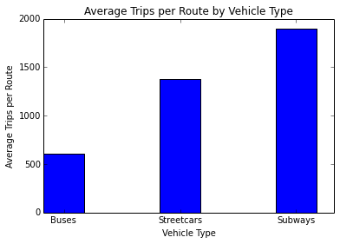
Streetcars: 1375.5 trips per route
Buses: 611.0060240963855 trips per route
Subways: 1896.5 trips per route

Geographic Distribution of Bus Stops
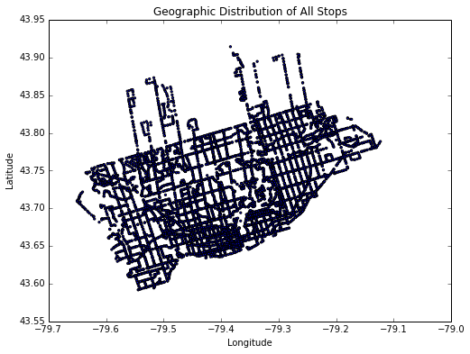

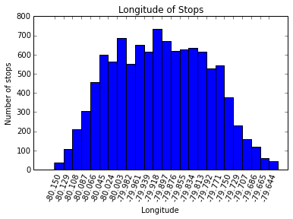

Longitudes: count 10738.000000
mean -79.399878
std 0.110536
min -79.650347
25% -79.489651
50% -79.400623
75% -79.313075
max -79.123046
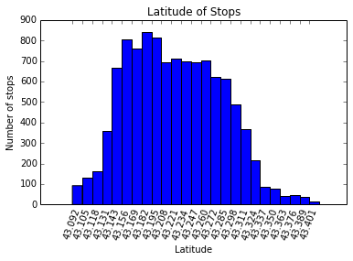

Latitudes: count 10738.000000
mean 43.725382
std 0.060305
min 43.591810
25% 43.677031
50% 43.721847
75% 43.771064
max 43.914362
Interestingly, the standard deviation of the longitudes is significantly larger than the standard deviation of the latitudes. This indicates that Toronto is a city that is wider on the east-west axes than the north-south axes. Both are roughly mound-shaped and symmetric, however.
For us, this means that as long as you don't live in the fringes of Toronto, such as very far north or very far east/west, there is an adequate supply of bus stops.

Live Vehicle Location Data
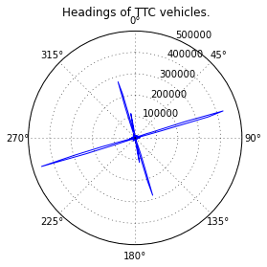
As expected, there are spikes heading north, east, south and west but very very little in between. The slight offset is likely due to Toronto's streets having an inclination, as seen in the geographic scatter plot of the buses. Another thing that's interesting, but also expected, is that the graph is mostly symmetrical -- vehicles spend the same amount of time heading east as they do west, and heading north as they do south. This also means that on average, vehicles travel at the same speed heading east and west, and north and south.
One item of note is that the east and west spikes are much larger than the north and south spikes. This indicates, like we saw earlier with the larger standard deviation in longitude, that Toronto's east-west axis is longer than Toronto's north-south axis.

Time Distribution
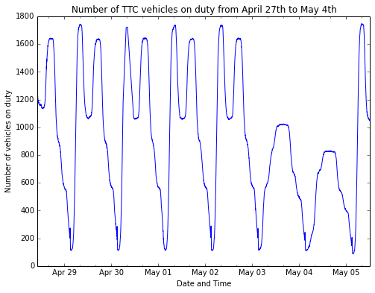
Even without looking at the exact times, there are many more buses and streetcars on the road during rush hour on weekdays than there are on weekends, and much more than there are at night. Weekdays follow a bimodal distribution, whereas weekends follow a modal distribution. Also, there are consistently more vehicles active during morning rush hour than evening rush hour on weekdays.
At the peak of Saturday service, there are only as just as many vehicles as there are during the least busy hours of weekdays. There are even fewer active vehicles during peak hours on Sundays.

Velocity
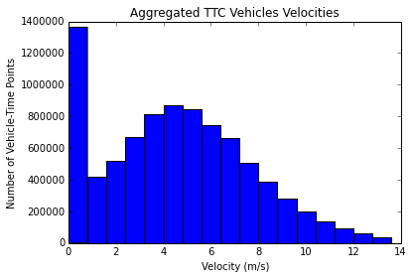
count 8617369.000000
mean 4.550967
std 3.079863
min 0.000000
25% 2.187578
50% 4.475319
75% 6.643428
max 13.522408
dtype: float64
IQR: 4.45584987475
Pearson's Index: 0.0736866892983
Range: 13.5224079069
As Pearson's Index indicates, there is slight right-skewing, but not very much. The range of the data is surprisingly small (after outliers were removed), from 0m/s (0km/h) to 13.5m/s (48.6km/h). Overall, the data is mostly mound-shaped and normal, except for a strong mode at 0 (likely due to resting vehicles / drivers) and a slight right skew.

Velocity and Time
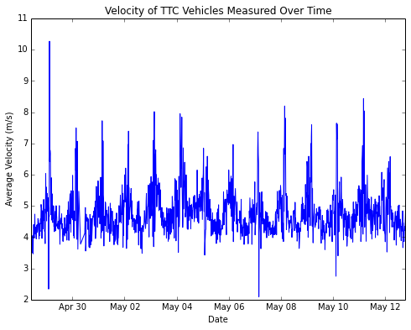
This clearly shows that the moving average velocity of vehicles is periodic, but it's hard to see from this plot when. Let's look specifically at the time of day and ignore the date.
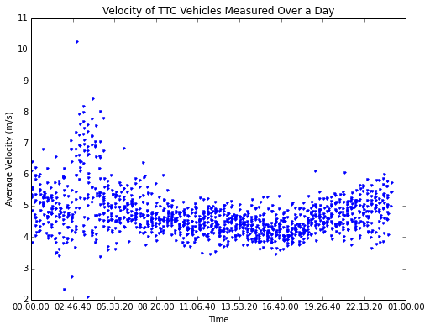
Interestingly, the TTC has its vehicles at the fastest very late at night. This is likely because there is little traffic and also much fewer other TTC vehicles, so they do not have to maintain as far of a spacing. As well, there are much fewer people at these hours, so vehicles do not have to make as frequent stops. However, there is also much higher variance, likely due to vehicles being ahead of schedule and making long stops in order to synchronize.
Overall through the day, TTC vehicles appear to be mostly uniform in speed, with an overall median speed of 4.5 m/s, or approximately 16km/h. This is remarkably slower than expected, since most streets have a speed limit of between 40km/h and 80km/h.

Correlating Velocities and Busyness
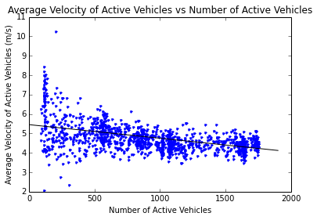

-------------------------Summary of Regression Analysis-------------------------

Formula: Y ~ <x> + <intercept>

Number of Observations: 1273
Number of Degrees of Freedom: 2

R-squared: 0.2501
Adj R-squared: 0.2495

Rmse: 0.6348

F-stat (1, 1271): 423.9162, p-value: 0.0000

Degrees of Freedom: model 1, resid 1271

-----------------------Summary of Estimated Coefficients------------------------
Variable Coef Std Err t-stat p-value CI 2.5% CI 97.5%
--------------------------------------------------------------------------------
x -0.0007 0.0000 -20.59 0.0000 -0.0008 -0.0007
intercept 5.4518 0.0381 143.14 0.0000 5.3771 5.5264
---------------------------------End of Summary---------------------------------

Punctuality
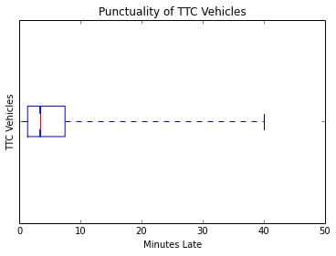
count 219122.000000
mean 5.580403
std 6.187868
min 0.000000
25% 1.350000
50% 3.416667
75% 7.466667
max 39.983333
dtype: float64
Pearson's index: 1.04902199392
Interquartile range: 6.11666666667
Data range: 39.9833333333

Here, we can see that the data is right-skewed, which makes sense since most vehicles arrive close to on top, whereas fewer and fewer vehicles arrive later. The Pearson's Index is greater than one, which confirms that the data is right-skewed.

Punctuality and Number of Trips
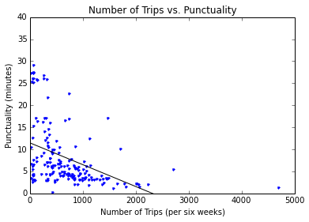
-------------------------Summary of Regression Analysis-------------------------

Formula: Y ~ <x> + <intercept>

Number of Observations: 172
Number of Degrees of Freedom: 2

R-squared: 0.1862
Adj R-squared: 0.1814

Rmse: 6.2380

F-stat (1, 170): 38.9004, p-value: 0.0000

Degrees of Freedom: model 1, resid 170

-----------------------Summary of Estimated Coefficients------------------------
Variable Coef Std Err t-stat p-value CI 2.5% CI 97.5%
--------------------------------------------------------------------------------
x -0.0050 0.0008 -6.24 0.0000 -0.0065 -0.0034
intercept 11.4722 0.7205 15.92 0.0000 10.0601 12.8844
---------------------------------End of Summary---------------------------------
The fit, although weak in the strict sense (R-squared = 0.1862), does indicate that an increase in number of trips tends to decrease the median time waiting for a route. This makes sense, since more frequent vehicles means that even if one is missed, or is late, it is very difficult for many vehicles to be late at once.

Ridership and Punctuality
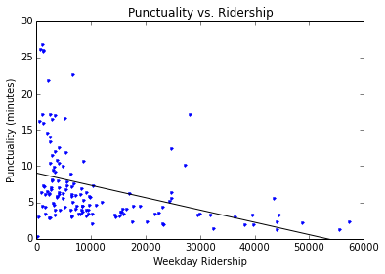
-------------------------Summary of Regression Analysis-------------------------

Formula: Y ~ <x> + <intercept>

Number of Observations: 136
Number of Degrees of Freedom: 2

R-squared: 0.1538
Adj R-squared: 0.1475

Rmse: 5.0319

F-stat (1, 134): 24.3621, p-value: 0.0000

Degrees of Freedom: model 1, resid 134

-----------------------Summary of Estimated Coefficients------------------------
Variable Coef Std Err t-stat p-value CI 2.5% CI 97.5%
--------------------------------------------------------------------------------
x -0.0002 0.0000 -4.94 0.0000 -0.0002 -0.0001
intercept 9.0460 0.5849 15.47 0.0000 7.8996 10.1924
---------------------------------End of Summary---------------------------------
This indicates that there is a weak negative correlation between the number of riders and the average lateness of the routes. This is expected, since routes with more riders tend to come more frequently and thus are less late less often than routes with fewer riders.

Weather
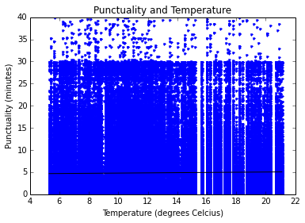
-------------------------Summary of Regression Analysis-------------------------

Formula: Y ~ <x> + <intercept>

Number of Observations: 491464
Number of Degrees of Freedom: 2

R-squared: 0.0003
Adj R-squared: 0.0003

Rmse: 5.5336

F-stat (1, 491462): 154.5662, p-value: 0.0000

Degrees of Freedom: model 1, resid 491462

-----------------------Summary of Estimated Coefficients------------------------
Variable Coef Std Err t-stat p-value CI 2.5% CI 97.5%
--------------------------------------------------------------------------------
x 0.0241 0.0019 12.43 0.0000 0.0203 0.0279
intercept 4.5434 0.0241 188.32 0.0000 4.4961 4.5907
---------------------------------End of Summary---------------------------------
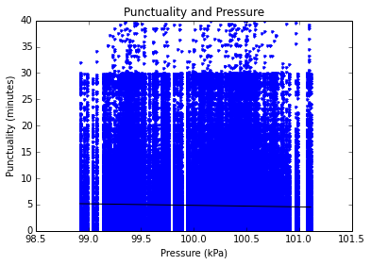
-------------------------Summary of Regression Analysis-------------------------

Formula: Y ~ <x> + <intercept>

Number of Observations: 491464
Number of Degrees of Freedom: 2

R-squared: 0.0008
Adj R-squared: 0.0008

Rmse: 5.5324

F-stat (1, 491462): 375.3727, p-value: 0.0000

Degrees of Freedom: model 1, resid 491462

-----------------------Summary of Estimated Coefficients------------------------
Variable Coef Std Err t-stat p-value CI 2.5% CI 97.5%
--------------------------------------------------------------------------------
x -0.2921 0.0151 -19.37 0.0000 -0.3217 -0.2626
intercept 34.0656 1.5092 22.57 0.0000 31.1077 37.0235
---------------------------------End of Summary---------------------------------
From this, we can see that neither temperature nor pressure has any real effect on the punctuality of the vehicles.

Probability Question
You realize that you missed the bus/streetcar that you were trying to catch, but the likelihood that you'll be late is inversely proportional to the number of trips the route has (since the more trips a route has, the more frequently they come.) If the number of trips per route is normally distributed with μ=597.156069 and σ=445.952944, what is the probability that the route has 700 or more trips?

Solution: First, we find the z-score. z=x−μσ

Thus, P(x≥700)=P(x>699.5). Then the z-score is equal to 0.2295. Looking at the z-score table, we find that a z-score of 0.2295 corresponds to P(z>0.2295)=40.92%.

Conclusion
We can conclude that most routes are mostly punctual, that higher frequency routes do correlate with more punctual routes, that routes with higher ridership do correlate with higher punctuality, that faster routes don't correlate with ridership and that weather does not correlate with punctuality. Some sources of error included unclear documentation, a noisy algorithm for determining time or arrival of stops, as well as different formats of information from different sources.
Further research could be conducted on the accuracy of prediction services, a deeper in-depth study with subways and possibly including policy recommendations, as well as creation of a prediction service that involves all the factors studied.

References
City of Toronto Open Data (March 2014). TTC Routes and Schedules. Retrieved from http://www1.toronto.ca/wps/portal/contentonly?vgnextoid=96f236899e02b210VgnVCM1000003dd60f89RCRD
City of Toronto Open Data (April 2014). Next Vehicle Arrival System. Retrieved from https://www1.toronto.ca/wps/portal/contentonly?vgnextoid=4427790e6f21d210VgnVCM1000003dd60f89RCRD
Toronto Transit Commission (n.d.). TTC Transit Planning. Retrieved from http://www.ttc.ca/About_the_TTC/Transit_Planning/index.jsp
Toronto Transit Commission (2012). Surface Ridership. Retrieved from http://www.ttc.ca/About_the_TTC/Transit_Planning/Surface_Ridership_2012.jsp
Toronto Transit Commission (2013). TTC Subway Ridership 2012-2013. Retrieved from http://www.ttc.ca/PDF/Transit_Planning/Subway_ridership_2012-2013.pdf
Statistics Canada (2011). Commuting to Work. Retrieved from http://www12.statcan.gc.ca/nhs-enm/2011/as-sa/99-012-x/99-012-x2011003_1-eng.cfm

